IHE Work Item Proposal (Detailed)

# Proposed Work Item: 360X – Closed Loop Referrals

Proposal Editor: Brett Andriesen, ONC  
Work item Editor: Rob Rose, Hans Buitendijk, Catherine Britton - Cerner; Vassil Peytchev - Epic; Tiffanie Hickman – KHIN; Stephen Beller - NHDS   
Date: 9/26/2016  
Version: 1.0Domain: Patient Care Coordination

**Summary**

Among providers with heterogeneous EHR technology, tracking referrals and any necessary follow-up information is often difficult and time-consuming, and a large number of referrals not getting completed. With 360X, both the referring provider and the specialist (or provider receiving the referral) have better information about the patient, and about the care they have received in order to close the referral loop and provide better care.

Using XDM (and its Direct flavor), C-CDA, and HL7 v2 messages, there are opportunities to greatly improve the referral process using existing standards that have a fairly low bar for implementation within the USA.

The 360X implementation guide has already gone a long way in detailing how these existing standards and specifications could be implemented in a way that provides enhanced support to providers that refer patients to specialists. The work done by the group has also resolved many of the primary workflow issues, with clinical review and support by the American Medical Association (AMA).

Epic and Cerner have taken a leadership role in the development and completion of the Implementation Guide, with nearly twenty other vendors on the group’s listserv that are waiting for more concrete action and direction on the Implementation Guide before devoting additional resources toward development and implementation. Including 360X as a national extension to the part of IHE International’s PCC Technical Framework body of work in this area will signal to the developer community that 360X has matured enough that it will be worth expending resources to develop and include support for 360X as part of their products.

# The Problem

Today when a primary care provider refers a patient to another provider or clinic for specialty care, the health IT utilized often does not provide adequate tools or information to ensure that both providers have sufficient information about the patient and about the state of the referral. Recent studies indicate that roughly 60%-70% of referrals go unscheduled. When referrals are scheduled, 68% of specialists report not having received information from the patient’s primary care provider prior to the referral visit, and one-quarter of primary care providers do not receive timely information from specialists following the referral. Without effective health IT tools to facilitate communication and tracking of the referral process, providers resort to performing duplicate tests, and patients may miss out on vital care.

In cases where the two providers are using the same EHR environment, there are often proprietary tools that health IT developers have implemented to support the referral process. To more fully realize the benefits of health IT, the Office of the National Coordinator for Health Information Technology (ONC), through the State HIE Program, instantiated the 360Exchange (360X) Project in 2012 to accelerate interoperable health care data exchange in heterogeneous EHRT environments. In particular, the 360X Project seeks to enable providers—using existing health data exchange standards and technologies—to exchange:

* Referral requests containing relevant patient clinical information
* Additional information during the episode of care as needed (optional)
* Result of referral containing relevant patient clinical information

from within their workflow, regardless of the EHR technology used. This will allow providers to communicate electronically the related patient information even if utilizing different EHRT/HIT. This scope indicates that the 360X Project includes defining the transport and content of:

* the Referral Request
* the Result of Referral
* Additional information to facilitate the referral process and closing the loop.

This scope is intended to enable improved care coordination between providers utilizing different EHR technology.

# Use Cases

Mr. Packton, age 58, presents to Dr. Allen's office on September 2nd, 2016, with complaints of shortness of breath. The patient has a BMI of 30, no history of smoking, no complaints of chest pain, no physical signs of respiratory and cardiac problems, and a familial history of coronary artery disease.

Without 360X:

Dr. Allen, his PCP, orders a referral to a cardiologist, and sends a fax with Mr. Packton’s visit summary and a referral request to the cardiologist for further review.

The cardiology practice receives the fax, calls Mr. Packton, and schedules an appointment for September 8th, 2016. Mr. Packton keeps the appointment with Dr. Brown, and unfortunately is diagnosed with coronary artery disease and a cardiac catheterization is scheduled.

Dr. Allen’s practice has no way to know whether the appointment was scheduled, whether Mr. Packton kept the appointment as scheduled, what the diagnosis was, or that a catheterization was scheduled. To track this information, members of Dr. Allen’s care team must expend resources to obtain this information, and remember to do so using manual processes.

Using 360X:

Dr. Allen, his PCP, orders a referral to a cardiologist, stating the clinical question as “Determine the origin of Mr. Packton’s shortness of breath”. Based on the practice's workflows and the PCP's system's handling of referrals, a referral package is created, which contains:

* the above noted findings
* demographic information
* patient history
* lab results
* patient insurance

The referral request is sent to the cardiologist's practice. The cardiology practice receives the referral request, sends for and receives prior authorization, and based on the practice's workflows and their system's handling of referral requests, an affirmative response to the request is sent to Dr. Allen's practice.

Dr. Brown's office at the cardiology practice calls Mr. Packton, and schedules an appointment on September 8th, 2016. Based on the practice's workflows and their system's handling of referral requests, a notification is sent of the appointment date/time to Dr. Allen. Mr. Packton keeps the appointment with Dr. Brown, and unfortunately he is diagnosed with coronary artery disease and a cardiac catheterization is scheduled.

Dr. Brown's initial consultation note is completed and it is sent to Dr. Allen, answering the clinical question and stating the date of the cardiac catheterization. After the catheterization is performed, the results are reviewed by Dr. Brown, and a final consultation note is sent to Dr. Allen, including a suggested plan of care. Dr. Allen reviews the consultation notes and closes the referral loop.

# Standards & Systems

The implementation guide focuses on point to point exchanges between organizations using EHR Technology, as defined by the US regulations regarding Meaningful Use.

The standards used are: [XDM](http://www.ihe.net/uploadedFiles/Documents/ITI/IHE_ITI_TF_Vol2b.pdf); [XD Metadata](http://www.ihe.net/uploadedFiles/Documents/ITI/IHE_ITI_TF_Vol3.pdf); HL7 v2.x Messaging; HL7 C-CDA (Summary of Episode Note, Consultation Note, or Referral Note preferred); [Direct Applicability Statement](http://wiki.directproject.org/file/view/Applicability+Statement+for+Secure+Health+Transport+v1.1.pdf); [XDR / XDM for Direct Messaging Specification](http://wiki.directproject.org/file/view/2011-03-09%20PDF%20-%20XDR%20and%20XDM%20for%20Direct%20Messaging%20Specification_FINAL.pdf);

# Technical Approach

## Assumptions and Constraints

The technical approach is based on the following goals, assumptions, and constraints:

* The focus is on sharing clinical information between the referral initiator and the referral recipient.
* Whenever possible, maintain separation of concerns
* The technical approach needs to maximize the capabilities present in existing EHR technology investments in the US, as required by MU2, MU3, and subsequent regulations
* The bar for participating in a 360X exchange should be as low as possible while providing the capability for future extensions in a gradual manner, without requiring major changes to the underlying technical approach.

## State Transitions for the Referral Workflow

The exchange of information between a Referral Initiator and a Referral Recipient can be generalized in the following state transition diagrams. One of the goals of the 360X specification is to allow the workflow, in the vast majority of its instantiations, to reach either a successful, or an exceptional state without the need of manual intervention. Manual interventions, however, cannot be avoided 100% of the time, and those rare cases are called out, and considered out of scope for the specification.

The state transitions from the point of view of the Referral Initiator are as follows:

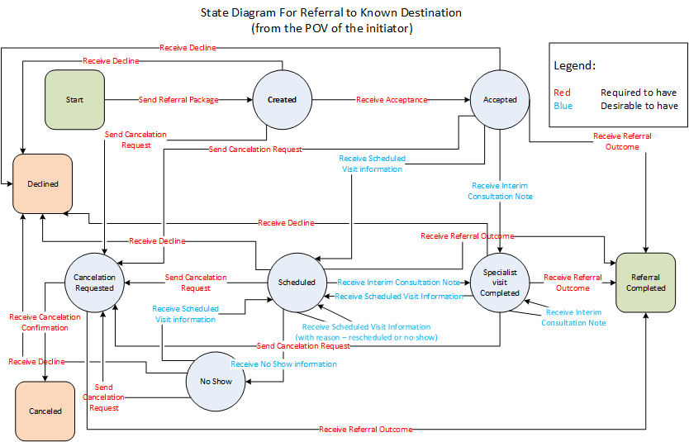

The same states, but with state transitions from the point of view of the Referral Recipient:

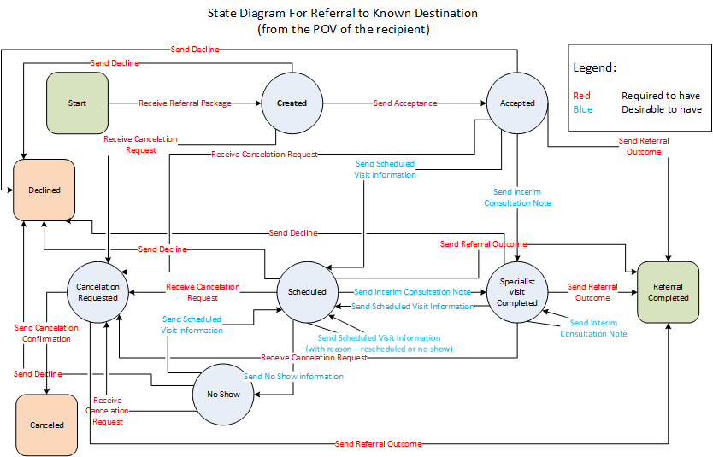

It is important to note that the specification is concerned with the transactions, which drive the transitions from state to state, and not with the states themselves. There are no specific requirements for how these states are to be externalized/displayed (if at all) within a given EHRT’s end user interface. For example, once a newly "Created" referral package has been sent to the Referral Recipient, it may be shown as "pending" in the Referral Initiator's EHRT and may be displayed in the work queue of the Referral Recipient 's EHRT as "new" or some other suitable status. In this way, the 360X implementation guide provides a mechanism by which disparate EHRT may infer the state/status of a referral based on prior messages while retaining the ability to integrate this flexibility into a given application's workflow.

## Transport

The transport is based on the IHE ITI XDM profile, ZIP over Email option, and ZIP over Email Response option. The profile is further constrained according to the Direct Applicability Statement, and the XDR and XDM for Direct Messaging Specification.

The choice of transport was made based on the requirement that any certified EHR Technology product in the US must support the Direct Applicability Statement, and there are no other transport mechanisms that are nationally required by MU2, MU3 or any existing subsequent regulations.

The use of XDM, and the Submission Set mechanism in particular, is necessary to provide the ability to group together multiple document entries for the purposes of the referral, thus facilitating the transmission of workflow data. The cross-profile metadata framework for document sharing also allows for further gradual extensions of the capabilities of 360X.

## Contents of the Submission Set

We require the use of the HL7 C-CDA Implementation Guide, DSTU 2.1, for the exchange of clinical information, and small set of HL7 V2.x messages for the exchange of workflow information. These base specifications are constrained to reflect the needs of the 360X specification.

The choice of the C-CDA Implementation Guide was made based on the 2015 Edition of the ONC requirements supporting MU stage 3, which includes the electronic transmission of C-CDA documents. The 360X specification further describes the particular document types, and section and entry templates that support the exchange of clinical information as part of a referral workflow.

The choice of the HL7 v2.x messages was made based on the existing use of such messages to exchange laboratory orders and results between certified EHRT and reference lab systems. We believe that using a format and content that is already familiar to EHRT implementers provides a lower bar to implementing a 360X compliant solution, than using a format which is not as familiar.

## New Actors

The specification uses the following two actors to express the combined capabilities of transport, content creation, and content consumption functionality:

|  |  |  |
| --- | --- | --- |
| **Actor** | **Role** | **Grouping of IHE actors** |
| Referral Initiator | Source of referral | Portable Media Creator Portable Media Importer Content Creator Content Consumer |
| Referral Recipient | Provider of referral services | Portable Media Creator Portable Media Importer Content Creator Content Consumer |

It is not clear whether this grouping of existing IHE actors requires the creation of new actors within the PCC technical framework, or if this can be just part of the national extension.

## Existing Actors

See above

## New Transactions

The specification discusses the following transactions, both in terms of processing requirements, and in terms of content:

|  |  |  |  |  |
| --- | --- | --- | --- | --- |
| **Portable Media Creator** | **Action** | **Event / Transaction** | **Portable Media Importer** | **Action** |
| Referral Initiator | R | Send Referral Request | Referral Recipient | R |
| Referral Recipient | R | Send Acceptance (of Referral Request) | Referral Initiator | R |
| Referral Recipient | R/C | Send Decline (of Referral Request) | Referral Initiator | E |
| Referral Recipient | R | Send Referral Outcome | Referral Initiator | E |
| Referral Initiator | C | Send Request for Cancellation | Referral Recipient | C |
| Referral Recipient | C | Send Cancellation Confirmation | Referral Initiator | E |
| Referral Recipient | O | Send Interim Consultation Note | Referral Initiator | R |
| Referral Recipient | O | Send “Scheduled Appointment” Notification | Referral Initiator | O |
| Referral Recipient | O | Send “No Show” Notification | Referral Initiator | O |

The requirements in “Action” columns refer to the preceding actor column:

* A Portable Media Creator
  + must be able to send the transactions marked as (R)equired from every state where the transaction occurs in the State Transition Diagram
  + depending on processing and workflow rules, and practice requirements, must be able to send the transactions marked (C)onditional in certain circumstances (of their choice)
  + may send the transactions marked as (O)ptional from the appropriate states in the State Transition Diagram.
* A Portable Media Importer
  + must process the transactions marked as (R)required in any of the states of the State Transition Diagram where that transaction occurs.
  + must process the transaction marked a (E)nd of workflow and present that to the appropriate users of its system
  + depending on processing and workflow rules, and practice requirements, must process the transactions marked (C)onditional in at least one of the states it is received according to the State Transition Diagram, but under certain conditions it may choose not to act on it.
  + may ignore transactions marked as (O)ptional, however, must not error out if they receive an optional transaction.

Note: The Referral Recipient must be able to send a Decline as a response to an initial referral request. The ability to send a decline from any other state is conditional upon local policies and workflow rules. That is why this transaction is marked as R/C for the Portable Media Creator.

## Impact on Existing Integration Profiles

This specification covers some of the functionality present in the Cross Enterprise Basic eReferral Workflow Definition (XBeR-WD) and Referral Order Linking (ROL) profiles. It is not clear how the 360X specification can be expressed as a constraint to one or both of them, and whether there may be a need to update one or both of them.

## New Integration Profiles Needed

The 360X specification is US- centric, and it is proposed as a National Extension of the PCC Technical Framework. Parts of it may be universally applicable, however (e.g., the state transition diagrams). It is not clear if that would lead to creation of a new profile, or updates to existing profiles.

## Breakdown of Tasks That Need To Be Accomplished

The following tasks are envisioned as part of making the 360X specification a US National Extension to the PCC Technical Framework:

* Review and improve existing work
* Add relevant value sets (where available) around the reason for referral/referral question
* Find the best alignment with existing profiles
* Determine the best approach to publish as a national extension

# Risks

If this national extension is not created and published, there will be no specification in the USA that builds upon the existing regulations and which could be referenced in future regulations. It is likely that a similar implementation guide built on newer specifications will be 5 to 10 years in the future.

Other IHE profiles exist for referral workflow management, but these have not seen a high level of adoption in the United States. 360X supports these same use cases, but does so using existing standards that can be implemented easier than several of the other resources we have been pointed to.

# Open Issues

* Relationship with existing profiles
* Format of the national extension
* Level of specificity for the C-CDA content

# Effort Estimates

<The technical committee will use this area to record details of the effort estimation.>